Chapter 3

3.1 Introduction
The Nykaa E-Commerce Database Management System is designed to efficiently manage the data and operations of an online beauty and personal care platform. It stores information related to customers, products, categories, brands, orders, payments, reviews, and administrators in a structured manner. The database ensures data accuracy, maintains relationships between entities, reduces redundancy, and supports efficient data retrieval, providing a reliable foundation for the smooth operation of the Nykaa e-commerce system.
3.2 Entity Relationship (ER) Diagram and Relationships

i. Customer

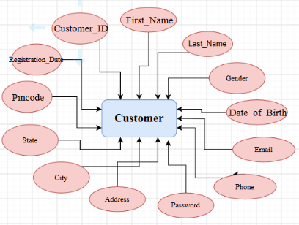

ii. Product
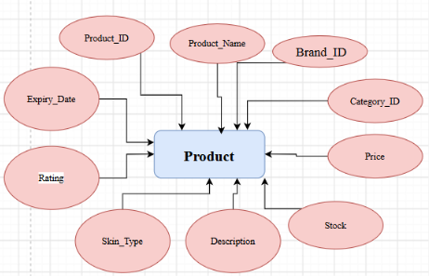
iii. Category
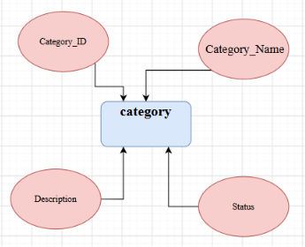
iv.Brand
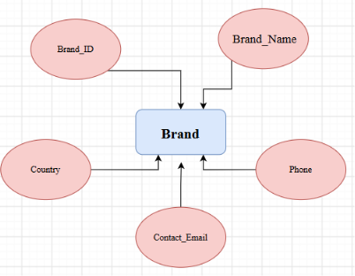

v. Cart
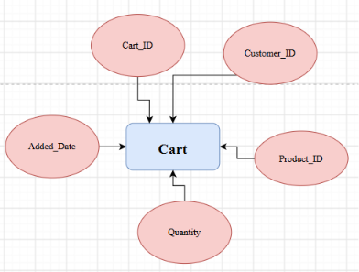

Vi.Orders
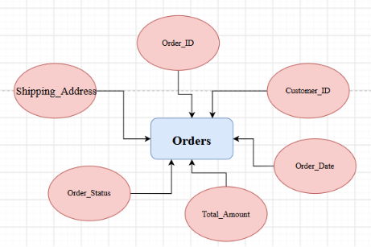
vii. Order Details
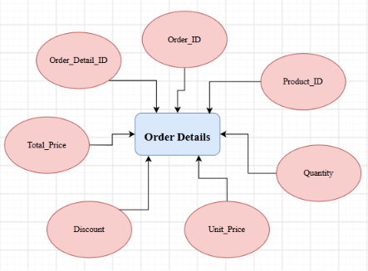
viii. Payment
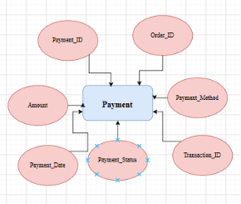

ix.Review
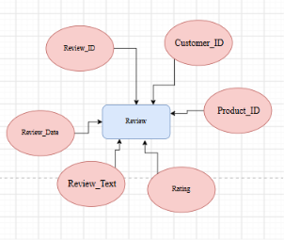

X. Admin
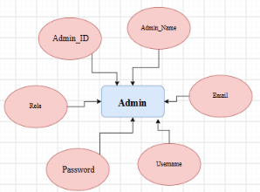

3.3 Relationships

